**Experiment 1:-** Design a LED Flasher

**Circuit Diagram:** 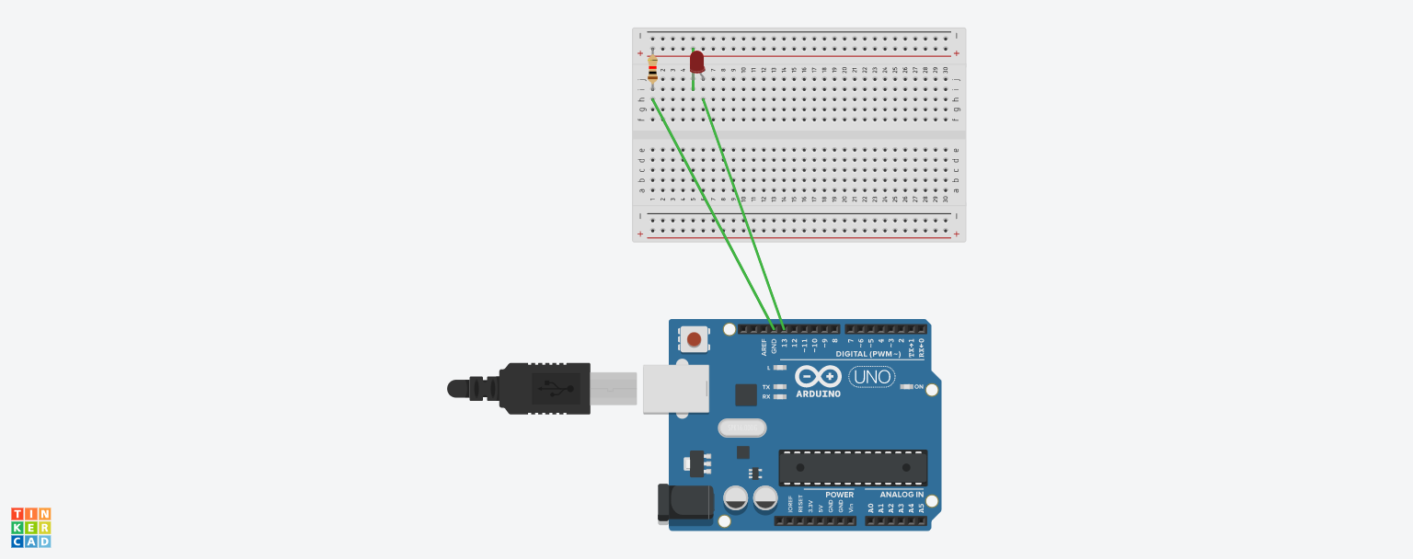

**Theory:-**

**Concept Used:-**

* The Arduino board can supply a power of 5V as digital output signals through the 14 pins present in it.
* The “GND” pin acts as ground.
* In the breadboard, the two rows present at the top and bottom each, are connected with each other in series and the columns present in between are connected in a set of 5 each. The connection pattern is shown below: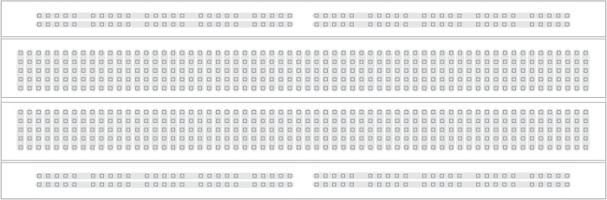

**Learning and Observation:-**

**Leanings:**

* Learned about how to make a series circuit using an Arduino board and a breadboard.
* Learned about how an Arduino works.
* Gained a practical experience of how an LED and a resistor work.

**Observations:-**

* When we pass electrical signals to the Arduino through our code the LED glow and gets off accordingly.

**Problems and Troubleshooting:-**

* The LED was short had to replace that.
* The circuit was not closed because of loose wires.
* **Precautions:-**
* The connections should be checked to see if they are inserted properly.
* The two pins of the LED should be connected at their appropriate points.
* We should take care that the circuit is closed.

**Learning Outcomes:-**

* Learned how to make circuits using Arduino board and bread board.
* Gained the skill of making a circuit using different hard wares and controlling that with the help of codes.